

**Purchase Game Tickets**

1. Visit hillsboroughschools.org

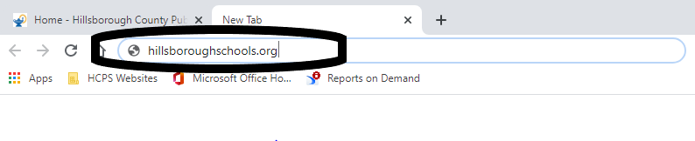

1. Select Departments



1. Select Athletics

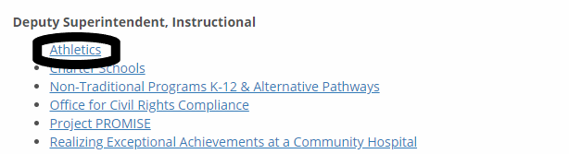

1. Select View Events By School



1. Select the **HOST** school of the game of interest



1. Select Get Tickets for the game of interest



1. Complete the transaction